Community Transparency Report
on the
Proposed Armory Data Center

Introduction
This report was prepared in response to questions raised by local community members regarding the proposed Armory Data Center in St. Louis. Residents asked for a clearer understanding of the project’s scale and its possible implications for electricity demand, utility costs, surrounding land use, nearby sensitive facilities, potential air emissions, and operational noise.
This analysis was conducted as an objective transparency effort. Its purpose is not to advocate for or against the project, but to present relevant data in a clear and accessible format so that residents, stakeholders, and decision-makers can better understand the issues involved.
Report Purpose
The purpose of this report is to:
- summarize the data gathered and visualized regarding the proposed Armory Data Centre
- provide context for understanding the scale of the proposal
- identify questions that may warrant further clarification
- support informed public discussion without taking a position on the project
Scope and Method
This report focuses on eight main areas:
- estimated electricity demand associated with the proposed facility
- recent residential electricity bill increases in Ameren Missouri territory
- population context in St. Louis City
- the project’s scale compared with existing local data centres
- proximity to nearby sensitive institutions
- noise context for data centre equipment and generators
- scenario-based backup generator emissions
- zoning and surrounding land use context
The analysis relies on publicly available data, reference documents, local mapping tools, and project-related information. Where project-specific technical details were not publicly confirmed, assumptions and estimates are noted.

Visualization 1: Electricity Demand Comparison
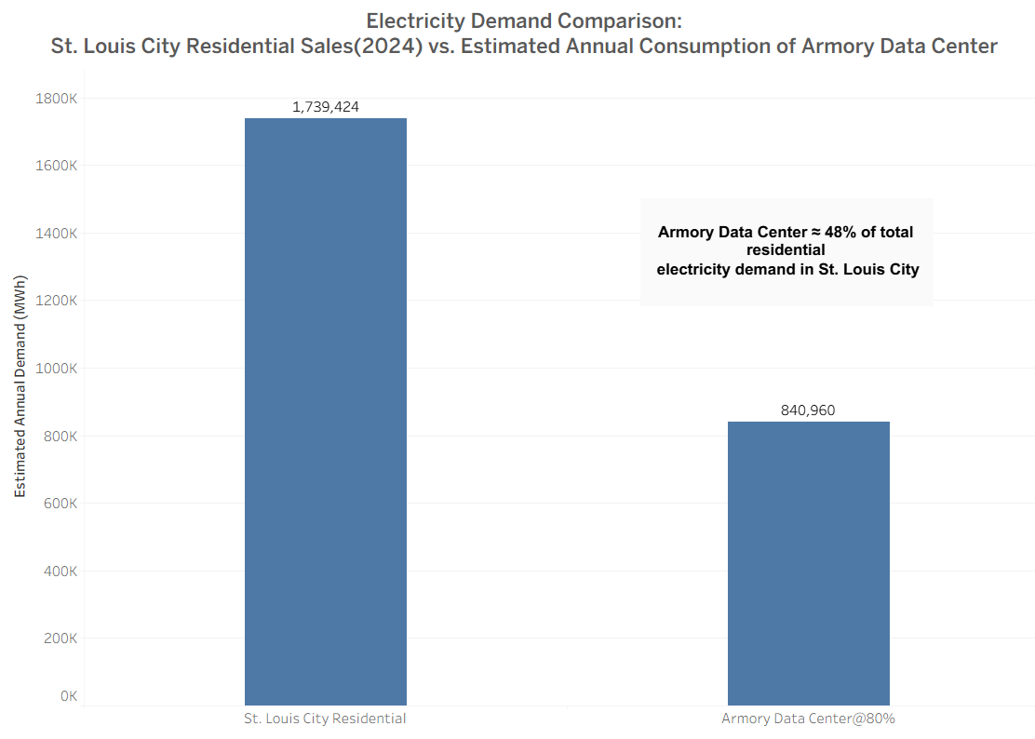Description
The first visualization compares estimated annual residential electricity demand in St. Louis City with the estimated annual electricity consumption of the proposed Armory Data Center.
Method
Using 2024 Missouri residential electricity data from the U.S. Energy Information Administration (EIA), specifically Table 8, Missouri residential electricity sales were divided by the number of residential customers to estimate average annual residential use per customer.[1] That average was then multiplied by the number of occupied housing units in St. Louis City using city census data.[2]
This produced an estimated St. Louis City residential electricity demand of 1,739,424 MWh.
The proposed Armory Data Center was estimated at 120 MW of capacity. Annual use at full operation was calculated as:
120 MW x 24 hours x 365 days = 1,051,200 MWh
Assuming an 80% utilization rate, estimated annual demand becomes:
1,051,200 x 0.80 = 840,960 MWh
Observation
At 80% utilization, the proposed Armory Data Center would consume approximately 840,960 MWh per year, equal to about 48% of estimated annual residential electricity demand in St. Louis City.
Interpretation
This comparison is intended to illustrate scale only. It does not mean residential customers would directly lose access to electricity, nor does it by itself show harm. It does, however, indicate that the project could represent a substantial new source of electricity demand.

Visualization 2: Ameren Missouri Residential Bill Trends
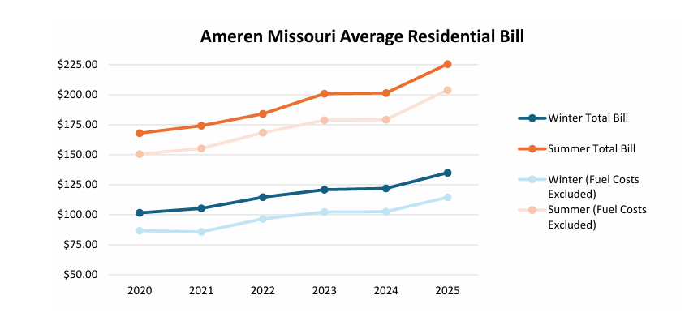
Description
The second visualization provides context on recent residential electricity bill increases in Ameren Missouri territory.
Source
This chart is based on MO-IOU Rate Analysis 2025.[3] The chart was included for reference, and credit for the underlying analysis belongs to the original report authors.
Observation
According to the source report:
- average summer residential bills increased by 34.3% from 2020 to 2025
- average winter residential bills increased by 32.9% from 2020 to 2025
The report further states that these increases were not primarily caused by rising fuel costs. Instead, fuel charges remained relatively steady while volumetric rates increased, and infrastructure investments appear to have been the principal driver of bill increases.[3]
Interpretation
This visualization does not show that the proposed Armory Data Centre caused prior bill increases. Rather, it provides context for why residents may be concerned about whether major new infrastructure demand could eventually have implications for household utility costs.

Visualization 3: St. Louis Population Trend
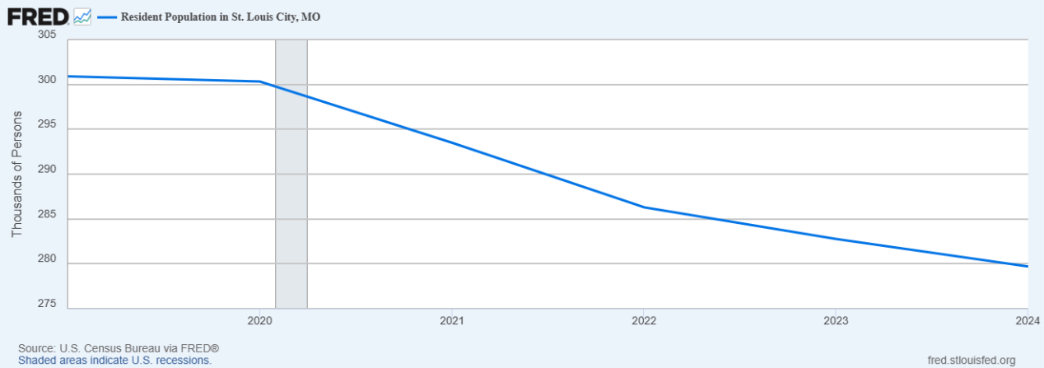

Description
The third visualization shows recent population decline in St. Louis City. The line chart was obtained from the Federal Reserve Economic Data (FRED) platform using the series Resident Population in St. Louis city, MO. [4]
Observation
The chart indicates that the city has experienced a downward population trend over the period shown.
Interpretation
This visualization is not evidence of project-specific impact. Instead, it provides broader city context. In a city facing population decline, residents may reasonably ask whether a large, resource-intensive development will deliver proportional local benefits, such as employment, tax value, neighbourhood activity, or broader community return.
Source Note
The chart was sourced directly from the Federal Reserve Economic Data (FRED) website using the St. Louis population series for the city.[4]

Visualization 4: Capacity Comparison with Existing Local Data Centers

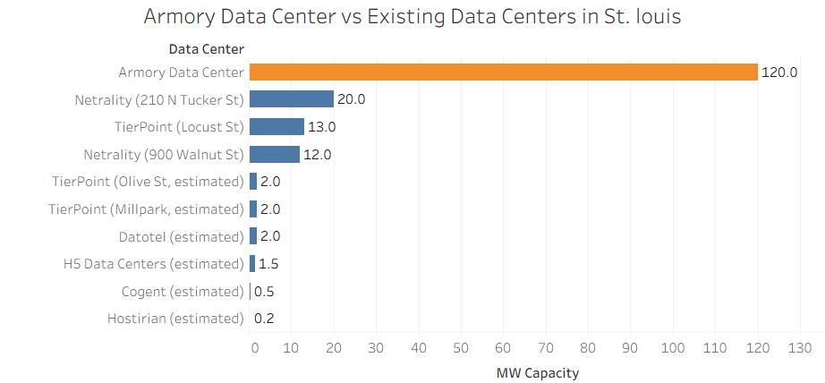
Description
The fourth visualization compares the proposed Armory Data Centre’s capacity with the estimated or reported capacities of existing data centres in the St. Louis area. To build this comparison, I first used the St. Louis data centre listing from Data Centre Map to identify existing facilities in the area.[5] I then reviewed the referral links associated with those listings to gather available facility information and used that information to estimate each site’s megawatt (MW) capacity where direct capacity figures were not publicly stated. The proposed Armory Data Centre was included at 120 MW based on project reporting.

Observation
The proposed Armory Data Centre is shown at 120 MW, while the largest existing facility included in the comparison is 20 MW. This suggests that the proposed facility would be approximately six times larger than the largest local comparison site shown.
Interpretation
This visualization helps place the project in local context. It suggests that the Armory Data Center would operate at a scale significantly larger than most current data centres identified in the St. Louis area. Although this does not prove a negative impact, it indicates that the facility may involve infrastructure and utility demands substantially greater than those associated with most existing local sites.
Source Note
Existing St. Louis-area data centres were identified using the Data Centre Map St. Louis listing, and referral links associated with those listings were used to collect available facility information and estimate MW capacity where necessary.[5]

Visualization 5: Sensitive Facilities Within a One-Mile Radius
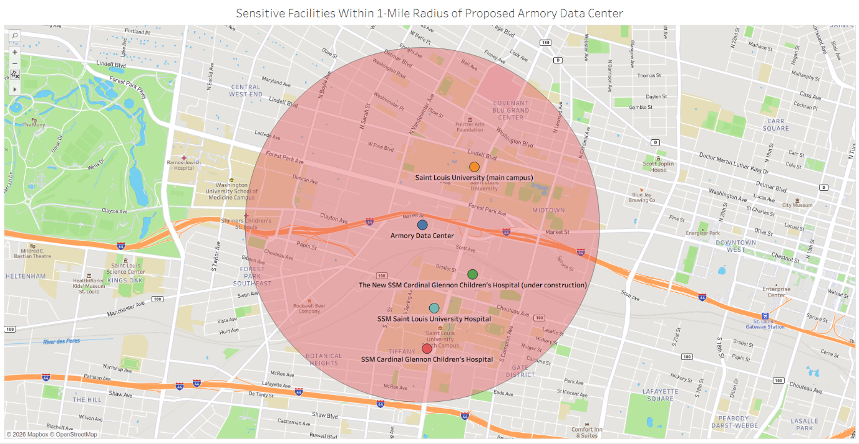
Description
The fifth visualization maps sensitive institutional facilities within approximately one mile of the proposed Armory Data Centre.

Observation
The map shows that the project site is located near several sensitive facilities, including:
- SSM Cardinal Glennon Children’s Hospital
- SSM Saint Louis University Hospital
- Saint Louis University main campus
- The New SSM Cardinal Glennon Children’s Hospital under construction

Interpretation
This map does not show that these institutions will be harmed. However, it does show that the proposed site is close to hospitals and university uses that may be more sensitive to operational disruptions, traffic changes, or other local environmental conditions. This makes proximity an important part of the overall context.

Visualization 6: Estimated Backup Generator Emissions Under Alternative Load Scenarios

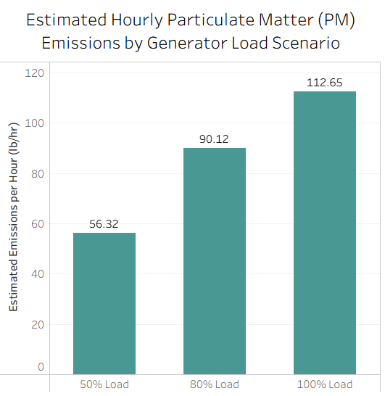
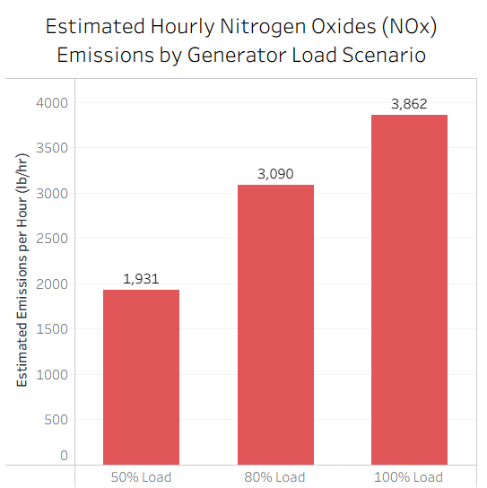
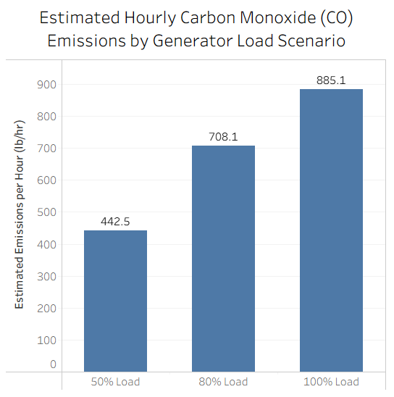
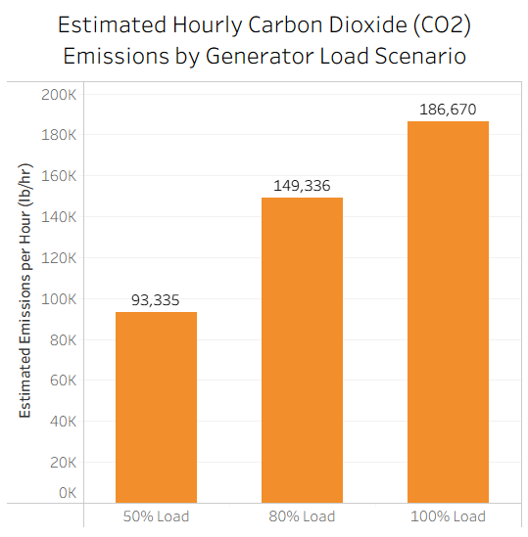
Description
The sixth visualization presents scenario-based estimates of hourly emissions from backup generators associated with the proposed Armory Data Center under three assumed generator load conditions: 50% load, 80% load, and 100% load. Separate charts were created for nitrogen oxides (NOx), carbon monoxide (CO), particulate matter (PM), and carbon dioxide (CO2) to show how estimated emissions increase as generator load increases.
Method / Source of Estimation
To estimate hourly emissions, the proposed facility capacity of 120 MW was converted to horsepower so it could be matched with emission factors expressed in lb/hp-hr. Emission factors were taken from the U.S. Environmental Protection Agency’s AP-42, Compilation of Air Pollutant Emission Factors, Section 3.4: Large Stationary Diesel and All Stationary Dual-Fuel Engines.[7]
For this visualization, diesel-engine emission factors from the lb/hp-hr (power output) column were used for the following pollutants: NOx (uncontrolled) at 0.024 lb/hp-hr, CO at 0.0055 lb/hp-hr, PM at 0.0007 lb/hp-hr, and CO2 at 1.16 lb/hp-hr.[7] The converted horsepower was then multiplied by each emission factor under assumed 50%, 80%, and 100% load conditions to estimate hourly emissions while generators are operating.

Observation
The visualization shows that estimated hourly emissions increase directly with generator load. Under the assumptions used in this analysis, the estimated emission rates are as follows:
NOx: 1,931 lb/hr at 50% load; 3,090 lb/hr at 80% load; 3,862 lb/hr at 100% load
CO: 443 lb/hr at 50% load; 708 lb/hr at 80% load; 885 lb/hr at 100% load
PM: 56.3 lb/hr at 50% load; 90.1 lb/hr at 80% load; 112.7 lb/hr at 100% load
CO2: 93,335 lb/hr at 50% load; 149,336 lb/hr at 80% load; 186,670 lb/hr at 100% load
Interpretation
This visualization is intended to illustrate the possible scale of generator emissions while operating under different assumed load conditions. It does not represent confirmed project emissions, and it does not estimate annual emissions as generator operating hours, final equipment specifications, fuel details, and emissions controls have not been publicly confirmed.
The visualization is useful as a transparency tool as it shows that potential emissions can vary substantially depending on generator load and design assumptions. In this context, it raises reasonable questions about what generator capacity, fuel type, emissions controls, and regulatory standards would apply to the proposed facility.
Important Source Note
The EPA document used for these estimates also states that AP-42 emission factors are not emission limits or regulatory standards and are not recommended by EPA for source-specific permit limits or compliance determinations.[7] For that reason, these charts should be interpreted as illustrative scenario estimates rather than as confirmed regulatory or project-specific values.

Visualization 7: Noise Context for Data Center Equipment and Backup Generators
Description
This section provides noise context for the proposed Armory Data Center by combining three reference tables rather than a single visualization. The tables present estimated source-level noise from major data centre equipment, the City of St. Louis noise performance table for relevant zoning districts, and EPA community noise guidance. The purpose is to show why operational noise may be an important issue for public review while distinguishing between internal or source-level noise and actual property-line noise.
Method / Source of Information
This section uses scenario-based source-level noise estimates for major equipment commonly associated with hyperscale data centers, along with local and federal reference tables for comparison. The internal or near-source estimates were drawn from a data center analysis published by Greening Chesapeake, which notes that large cooling equipment can reach about 100 dB(A) at the source and backup generators can reach about 110 dB(A) at the source.[8] These values are not property-line measurements.
To place those values in context, this section also includes the City of St. Louis noise performance table for zoning districts J-K [9] and EPA community noise guidance identifying levels associated with hearing protection and activity interference.[10]

Table 7.1
Estimated Source-Level Noise from Major Data Centre Equipment
Scenario | Noise Level (dB(A))
Hyperscale data centre equipment (fans/chillers) | Up to ~100
Backup generators | Up to ~110
Note. These values are source-level or internal-equipment estimates and are not property-line noise measurements.[8]

Table 7.2
City of St. Louis Noise Performance Table for Zoning Districts J-K
Tn* | Permitted Noise Level dB(A)
60 | 80 or less
30 | 81-83
15 | 84-86
8 | 87-89
4 | 90-92
2 | 93-95
0 | 96 or greater
Note. Tn* denotes the total duration, in minutes, that noise is emitted from the source during the measurement period. dB(A) denotes A-weighted sound pressure level. Table reproduced from the City of St. Louis code provision referenced by the user.[9]

Table 7.3
EPA Community Noise Guidance
Effect | Noise Level | Area
Hearing | Leq(24) < 70 dB | All areas (at the ear)
Outdoor activity interference and annoyance | Ldn < 55 dB | Residential outdoor areas and farms
Outdoor activity interference and annoyance | Leq(24) < 55 dB | Outdoor areas with limited exposure
Indoor activity interference and annoyance | Ldn < 45 dB | Indoor residential areas
Indoor activity interference and annoyance | Leq(24) < 45 dB | Other indoor areas (e.g., schools, hospitals)
Note. Leq(24) denotes the equivalent continuous sound level averaged over a 24-hour period. Ldn denotes the day-night average sound level, which includes an added nighttime penalty to reflect greater sensitivity to noise during nighttime hours. dB denotes decibels. Adapted from EPA community noise guidance.[10]
Observation
Taken together, these tables show that major data center equipment and backup generators can produce substantial noise at or near the source, while local ordinance thresholds and EPA guidance reference much lower levels depending on duration, location, and type of activity. The comparison suggests that source-level noise and community-facing noise are very different measurement contexts, and that mitigation and site design would be critical in determining actual neighborhood exposure.
Interpretation
This section is intended to show why noise is a relevant issue for the proposed project, especially given the site’s proximity to hospitals and university facilities. The equipment-level values in Table 7.1 should not be interpreted as expected property-line noise. Actual sound levels at surrounding properties would depend on enclosure design, building orientation, attenuation technology, the number of units operating simultaneously, duration of operation, testing schedules, shielding, and distance from the source.
Taken together, these tables suggest that property-line noise levels and mitigation strategies would be important areas for further clarification during project review. Information about expected boundary noise, operational conditions, and the measures proposed to maintain compliance with applicable limits would help provide a clearer understanding of potential community noise impacts.

Visualization 8: Zoning and Land Use Context
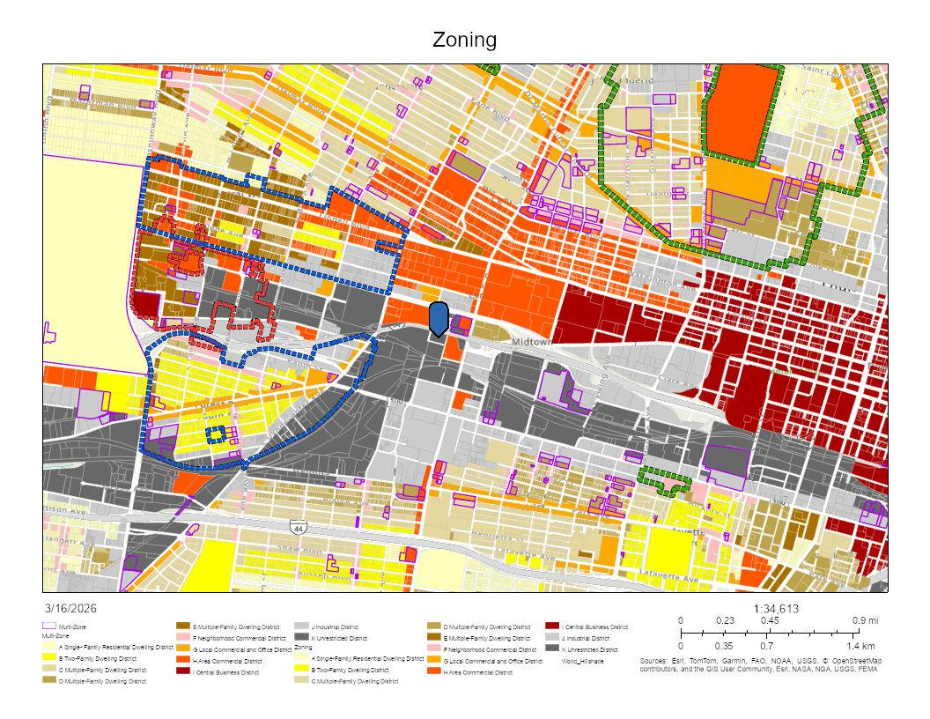

Description
The final visualization places the proposed site within its surrounding zoning and land use context using publicly accessible map information. [6]
Observation
The map shows that the proposed Armory Data Center site, identified by the blue marker, is located in an unrestricted zoning area and is surrounded in part by commercially zoned land.
Interpretation
This raises a broader planning question about whether a large data center, which may generate relatively limited street-level activity and foot traffic, represents the most suitable use for a site near commercially active areas. This does not mean the use is inconsistent with zoning. It simply highlights a land use question concerning neighborhood activity, visibility, and public-facing economic presence.

Overall Discussion
Taken together, these visualizations do not prove that the proposed Armory Data Centre will negatively affect the surrounding community. However, they do identify several areas where further clarification may be appropriate.
The project appears substantial in both electricity demand and facility scale. It is being considered in a context where residents have already experienced notable utility bill increases, where several sensitive institutions are located nearby, and where surrounding land uses raise questions about site suitability and neighbourhood character. The report also suggests that backup power systems and major equipment may be important to understanding how the facility would operate under real-world conditions, particularly in relation to emissions, noise, and regulatory compliance.
Because some of the technical information examined in this report is based on scenario-based estimates and reference tables rather than confirmed project specifications, these findings should be interpreted as indicators of areas where additional clarification may be warranted. In that sense, the analysis reinforces the importance of greater public detail regarding expected operating conditions, mitigation measures, and the standards that will govern project performance if the proposal moves forward.
These findings support further inquiry about whether the Armory Data Center should be developed, rather than final conclusions.

Questions for Decision-Makers
The visualizations in this report suggest several questions for further public review:
- What is the project’s expected annual electricity demand under typical operating conditions?
- What utility infrastructure upgrades, if any, would be needed to support the facility?
- Could any project-related infrastructure costs affect residential ratepayers directly or indirectly?
- What measurable local benefits are expected relative to the project’s energy demand and scale?
- How were nearby hospitals, university facilities, and other sensitive institutions considered in project review?
- What backup generator configuration is planned for the facility, and what fuel type will be used?
- What emissions controls, permits, and regulatory standards will apply to the backup generator system?
- How many hours per year are backup generators expected to operate for testing and emergency use?
- What are the expected property-line noise levels during normal operation, generator testing, and emergency operation?
- What sound attenuation technologies, enclosure specifications, and mitigation measures will be used to ensure compliance with local noise limits?
- What planning rationale supports this use at this location given the surrounding commercial context?
Limitations
This report is based on publicly available information and comparative estimates. Several limitations apply:
- some project-specific technical details were not publicly confirmed
- some capacity figures in local data center comparisons were estimated
- the emissions visualizations are scenario-based estimates rather than confirmed project emissions
- the noise context includes source-level estimates that are not equivalent to property-line measurements
- contextual charts do not by themselves establish project-specific impacts
- this report is not a substitute for a formal engineering, utility, or environmental review
Conclusion
This report was developed to improve public understanding of the proposed Armory Data Center by organizing available information into a clear set of visualizations and observations. At this stage, the material points more toward reasonable questions than definitive conclusions.
The proposal appears significant in scale, substantial in estimated electricity demand, and situated in a context that may make issues of infrastructure, planning fit, community benefit, emissions, and noise especially important. Additional project-specific disclosure will be valuable to support informed decision-making.

Closing Note
This analysis was prepared as an objective transparency effort to present relevant data in a clear and accessible format for residents, stakeholders, and decision-makers. Supporting materials and related project documentation are available in the project repository: https://github.com/Sriramd01/Community-Transparency-Report-on-the-Proposed-Armory-Data-Center

References
[1] U.S. Energy Information Administration, Missouri Electricity Profile 2024: https://www.eia.gov/electricity/state/missouri/
[2] St. Louis City Census Data, Housing Units: https://www.stlouis-mo.gov/government/departments/planning/research/census/data/
[3] MO-IOU Rate Analysis 2025: https://moconsumers.org/wp-content/uploads/MO-IOU-Rate-Analysis-2025.pdf
[4] Federal Reserve Bank of St. Louis. Resident population in St. Louis city, MO. FRED. https://fred.stlouisfed.org/series/MOSSPOP
[5] Data Center Map. St. Louis data centers list. https://www.datacentermap.com/usa/missouri/st-louis/
[6] Zoning map source: https://arcg.is/15DrCP3
[7] U.S. Environmental Protection Agency. AP-42, Compilation of Air Pollutant Emission Factors, Section 3.4: Large Stationary Diesel and All Stationary Dual-Fuel Engines. https://www.epa.gov/system/files/documents/2025-04/c03s04_april2025.pdf
[8] Greening Chesapeake. Analysis: Data centers in Chesapeake. https://www.greeningchesapeake.com/2025/07/data-center-analysis.html
[9] City of St. Louis, Missouri. Code of ordinances, Section 15.51.030. https://library.municode.com/mo/st._louis/codes/code_of_ordinances?nodeId=TIT15PUPEMOWE_DIVIVOFAGPUPE_CH15.51INNO_15.51.030PENOLETA
[10] U.S. Environmental Protection Agency. Information on levels of environmental noise requisite to protect public health and welfare with an adequate margin of safety. https://nepis.epa.gov/Exe/ZyPDF.cgi/2000L3LN.PDF?Dockey=2000L3LN.PDF

